**Software Requirement Specification**

**Project Name : - Clinic Management System**

Team Members : -

1- صموئيل مرزوق رزق

2- صديق حليم صادق

3- ابانوب عصام عياد

4- صبحي محمد صبحي

5- طارق عبدالعزيز

*1. Introduction*

1.1 Purpose : -

The purpose of this document is to describe the project to customers and developers .

1.2 Intended Audience and Reading Suggestions : -

Both lead developers and customers can check out this document

1.3 Product Scope : -

Through this project, the clinic is managed in modern ways, and through it, it is easier for the doctor to work and provide care to the patient by collecting his health data

*2 – Overall Description*

2.1 product perspective

The project is considered a site, and it is considered as an application of a previous system, but it has been updated through the user can inquire and book examinations.

2.2 Product Functions

patient functions :-

* login
* Registration
* Reservation(web site)
* patientEnquiry

Admin Functions :-

* Search(all data)
* Update
* login

Doctor functions: -

* Add Admin
* Enquiry (database)
* Registration (dashboard)

2.3 user Classes and Charateristics

1- user Who Can Register

2- Admin who Can Update , Delete ,and Register

3- owner who can do any function in system

2.4 Operating Enviroment

The Website can run in any platform

2.5 Design and implementation constraints : -

We will use C# (asp.net core )for Backend , Html , css and java Script for fornt End , MSsql for database

2.6 Assumptions and Dependencies

Contracting with all digital banking transactions, and the website supports Arabic and English

*3. External Interface Requirements*

3.1 User Interfaces : -

patient login form : -

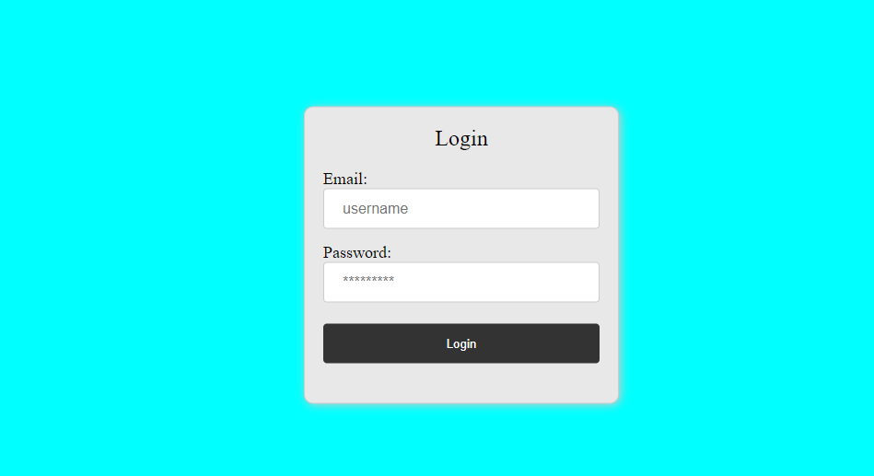

patient register form : -

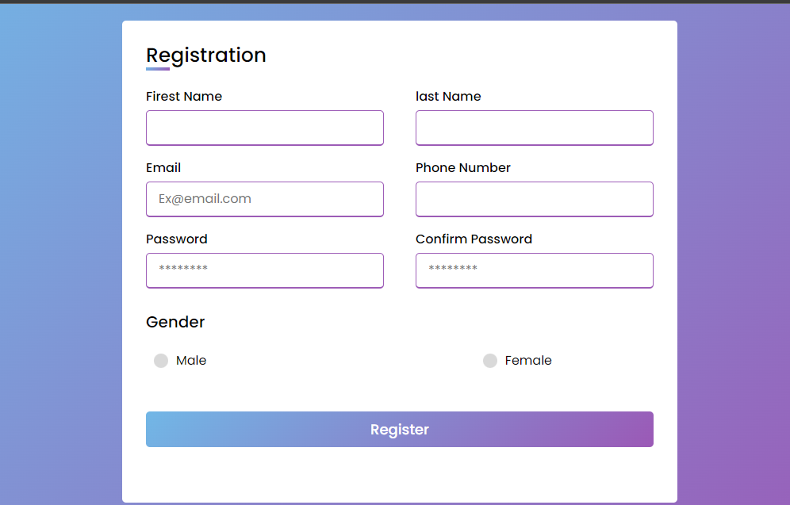

Main page : -

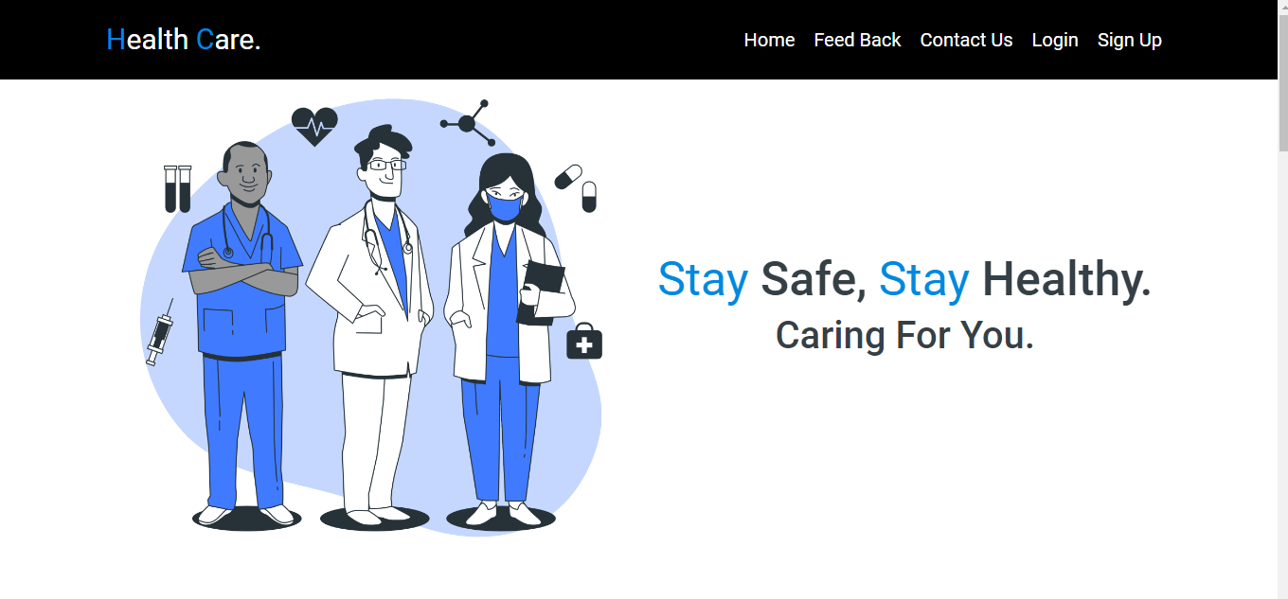

3.2 Hardware Interfaces : -

The project will need servers to service the site with a continuous 24-hour electric source, a printing machine inside the clinic, and a computer

3.3 Software Interfaces :

The site will work on any operating system

3.4 Communications Interfaces : -

In the clinic system we will use TCP Protocol Because it ensures that the information reaches the server correctly and will use HTTP protocol Be cauce it is used in web (sites , apps ) , the web site can run in any Operating system and any browser .

*4. System Features*

4.1 Erd :-

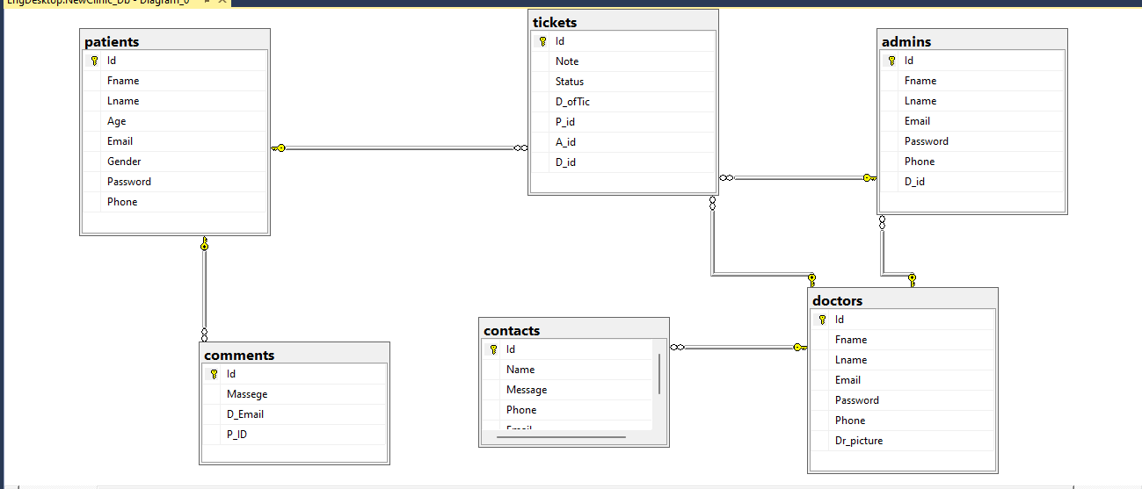

4.2 Use Case Diagram:

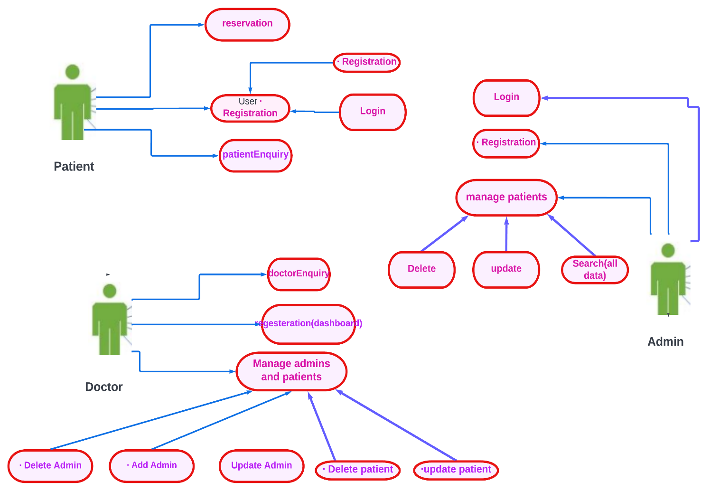

**4.3 Use Case Scenarios:**

**1)**

|  |  |  |
| --- | --- | --- |
| Use case Name | Reservation (clinic) | |
| Goal | Patient do a reservation | |
| Primary Actors | Patient | |
| Secondary Actors | none | |
| Precondition | Patient must login in our application | |
| Post condition |  | |
| Triggers |  | |
| Main flow | Step | Action |
| 1-  2- | User use email and password to login if he have ,if he have not do registeration.  Take an appointment if exist and pay in a clinic . |
| Extensions | 4.1 | If data invalid display “Invalid  selections” redirect to inventory  section window |

2)

|  |  |  |
| --- | --- | --- |
| Use case Name | Registration (login and Registration) | |
| Goal | Register in system | |
| Primary Actors | patient | |
| Secondary Actors | none | |
| Precondition | Patient must have an email. | |
| Post condition |  | |
| Triggers |  | |
| Main flow | Step | Action |
| 1-  1-  2- | If user has registered before  Write an email and password  If user has not registered before  User will use sin up to create email  Write his personal data |

3)

|  |  |  |
| --- | --- | --- |
| Use case Name | patientEnquiry | |
| Goal | Patient can search about his appointment | |
| Primary Actors | patient | |
| Secondary Actors | none | |
| Precondition | Patient must have an account | |
| Post condition |  | |
| Triggers |  | |
| Main flow | Step | Action |
| 1-  2-  3- | User login  Click on enquiry textbox  Search about his appointment |

4)

|  |  |  |
| --- | --- | --- |
| Use case Name | Login | |
| Goal | Admin can login patient | |
| Primary Actors | admin | |
| Secondary Actors | none | |
| Precondition | The patient is not registered | |
| Post condition |  | |
| Triggers |  | |
| Main flow | Step | Action |
| 1  2 | Write an email and password  Determine the patient appointment. |
| Extensions | 4.1 | Patient input is invalid and fast  Show an unsuccessful message |

5)

|  |  |  |
| --- | --- | --- |
| Use case Name | update patient | |
| Goal | Admin can update for the patients | |
| Primary Actors | admin | |
| Secondary Actors | none | |
| Precondition | Patient not must have an email. | |
| Post condition |  | |
| Triggers |  | |
| Main flow | Step | Action |
| 1  2  3 | admin clicks “update patient ” button  Write an email and password  Determine the patient appointment. |
| Extensions | 3.1 | Incorrect patient details, presentation  The message "unsuccessful" and  Offer to add a sick option |

6)

|  |  |  |
| --- | --- | --- |
| Use case Name | delete patient | |
| Goal | Admin can delete for the patients | |
| Primary Actors | Admin | |
| Secondary Actors | None | |
| Precondition | Patient must have an email. | |
| Post condition |  | |
| Triggers |  | |
| Main flow | Step | Action |
| 1 | admin clicks “delete patient ” button |
| Extensions | 4.1 | If user select “Yes” details are remove from the database. Else cancel the process |

7)

|  |  |  |
| --- | --- | --- |
| Use case Name | Reservation (dashboard) | |
| Goal | Admin can patient Reservation | |
| Primary Actors | admin | |
| Secondary Actors | none | |
| Precondition |  | |
| Post condition |  | |
| Triggers |  | |
| Main flow | Step | Action |
| 1  2 | The supervisor records the patient's data in terms of email and password  The supervisor sets an appointment for the patient |
| Extensions | 4.1 | If data invalid display “Invalid  selections” redirect to inventory  section window |

8)

|  |  |  |
| --- | --- | --- |
| Use case Name | Manage admin and patient | |
| Goal | Doctor can delete and update for the patients and admin | |
| Primary Actors | Doctor | |
| Secondary Actors | none | |
| Precondition |  | |
| Main flow | Step | Action |
| 1  2  3 | The doctor open the site  Doctor clicks “delete patient ” button  Doctor clicks “update patient ” button |
| Extensions | 4.1 | If invalid details entered Display  “not found” message and redirect  to main interface |
| 3.1 | Incorrect patient details, presentation  The message "unsuccessful" and  Show room management option. |

9)

|  |  |  |
| --- | --- | --- |
| Use case Name | Registration | |
| Goal | Register in system | |
| Primary Actors | Doctor | |
| Secondary Actors | none | |
| Precondition | Patient must have an email. | |
| Main flow | Step | Action |
| 1  2  3  4  5 | If user has registered before  Write an email and password  If user has not registered before  User will use sin up to create email  Write his personal data |

**4.5 Activity Diagrams:**

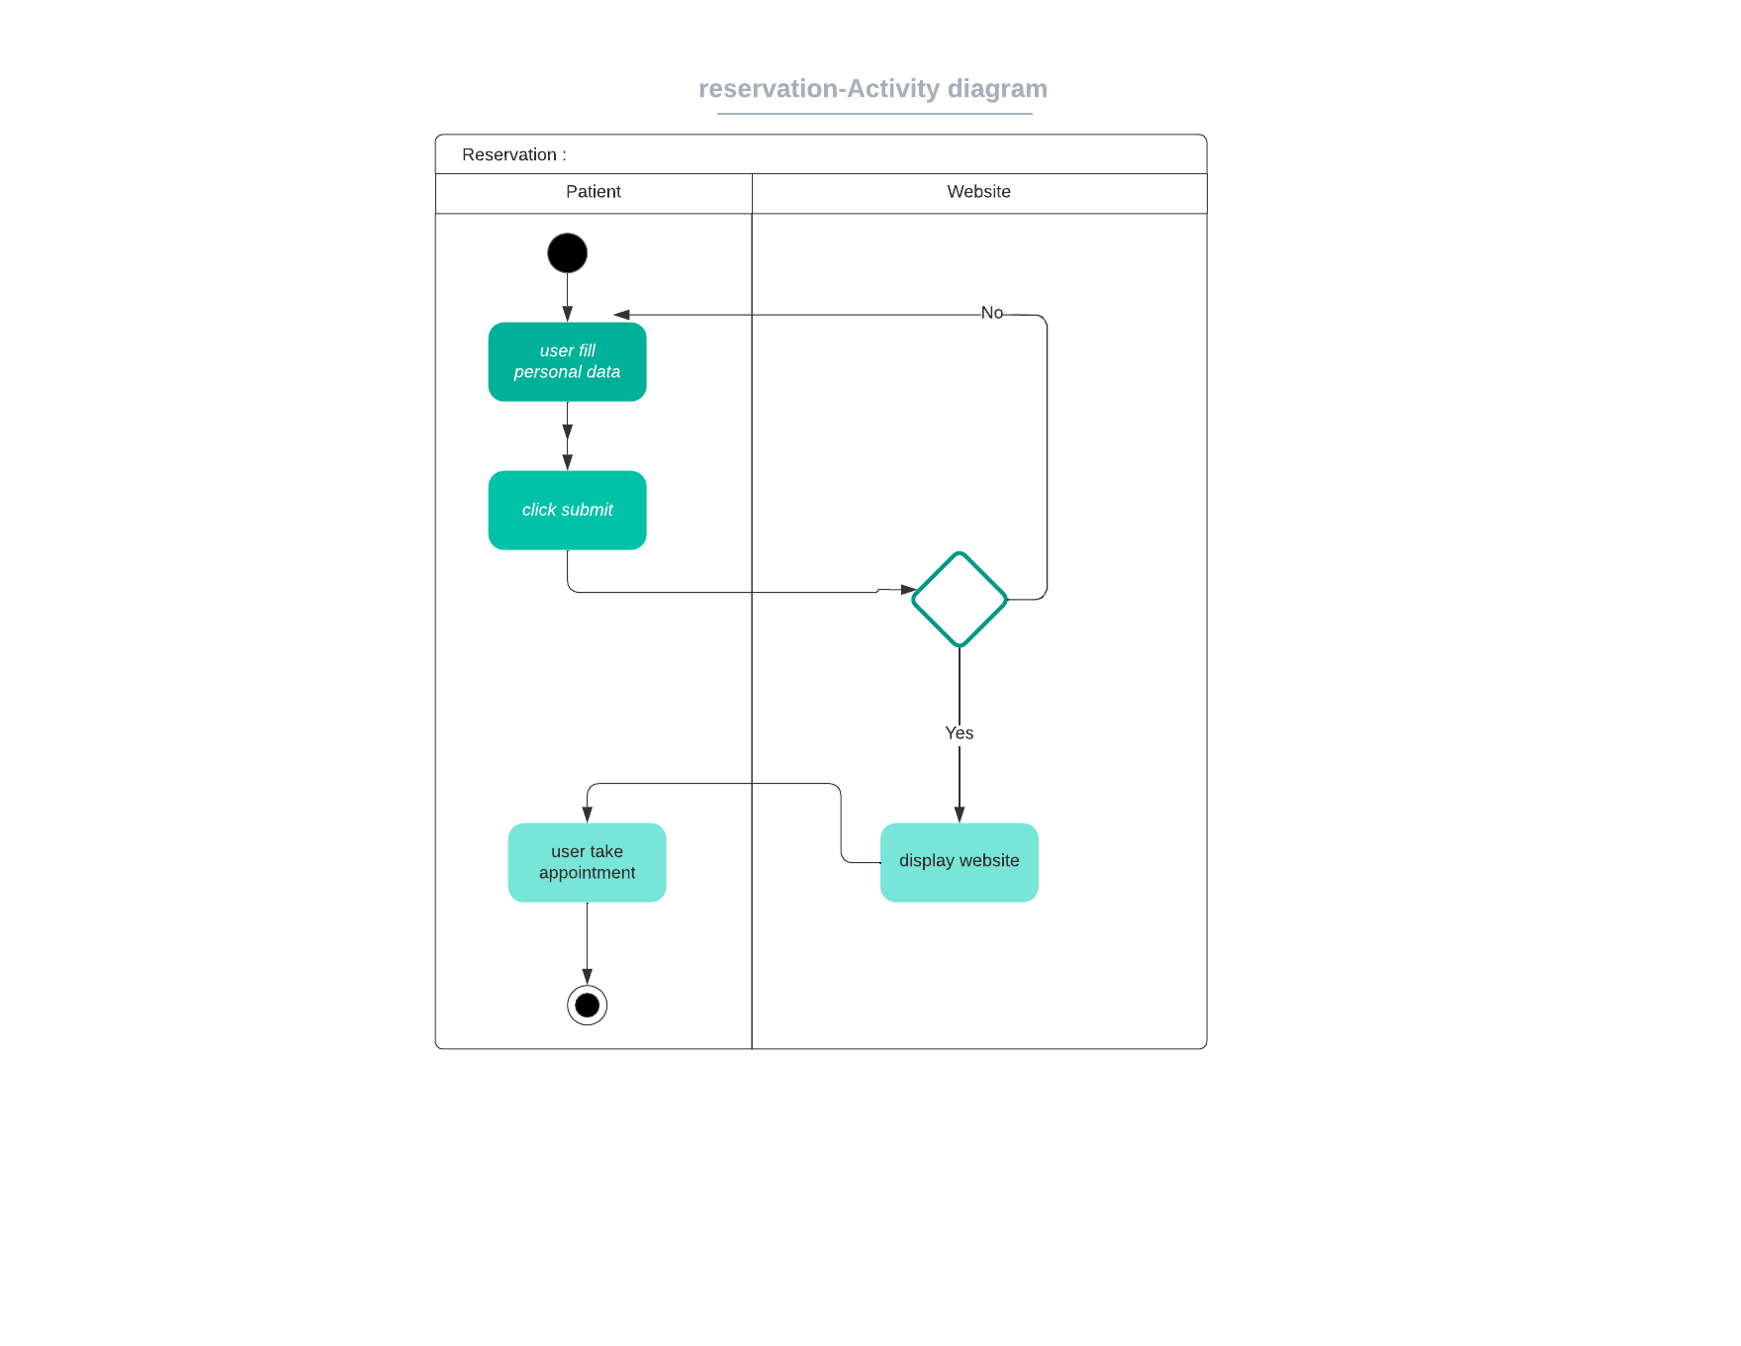

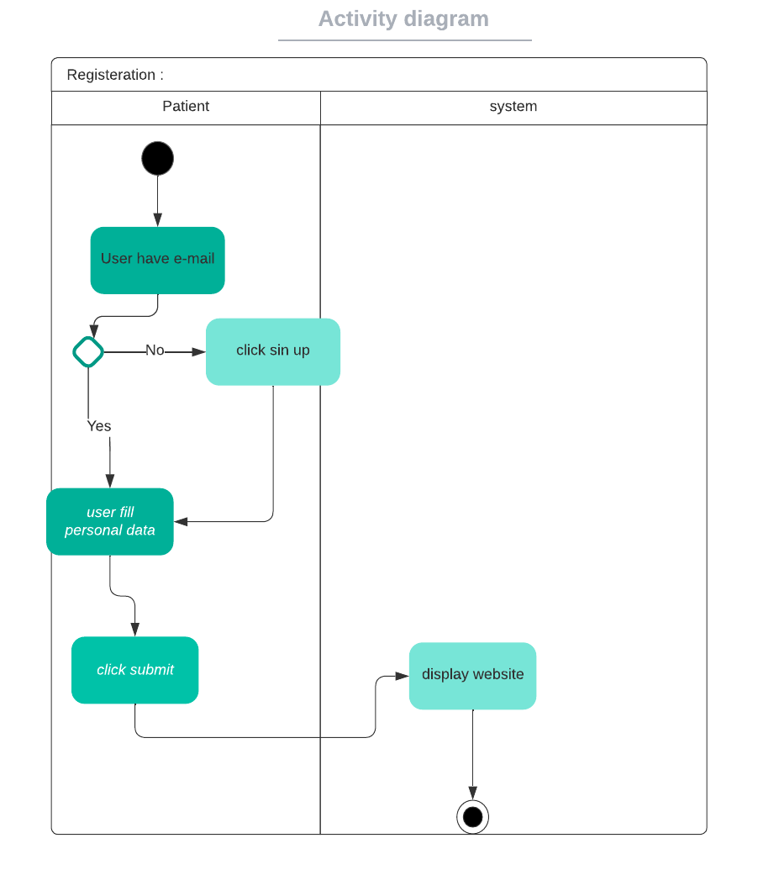

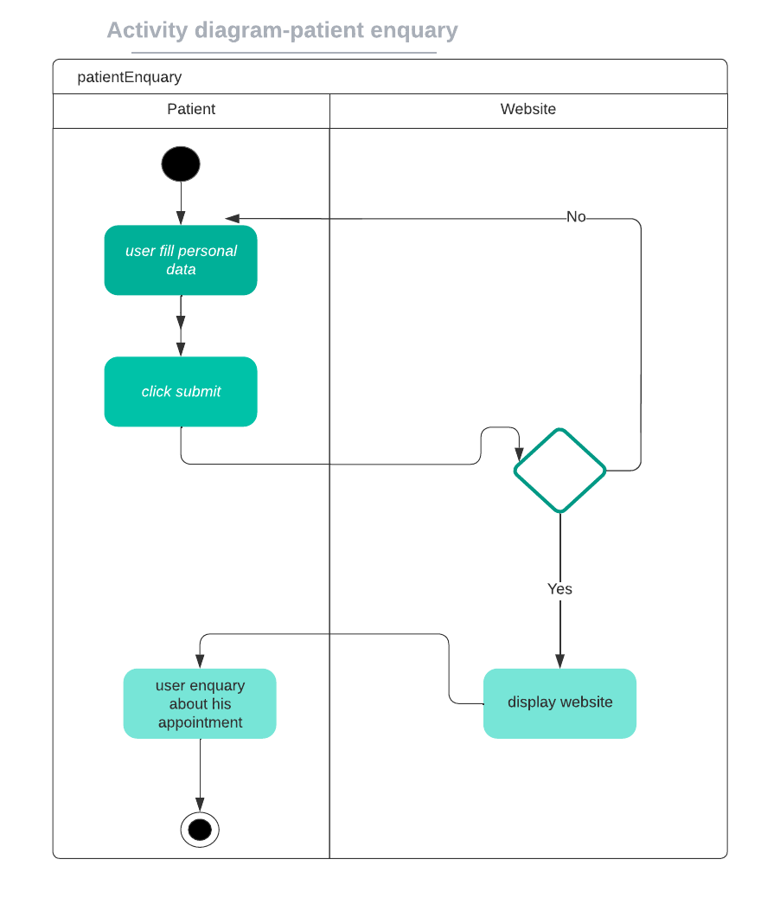

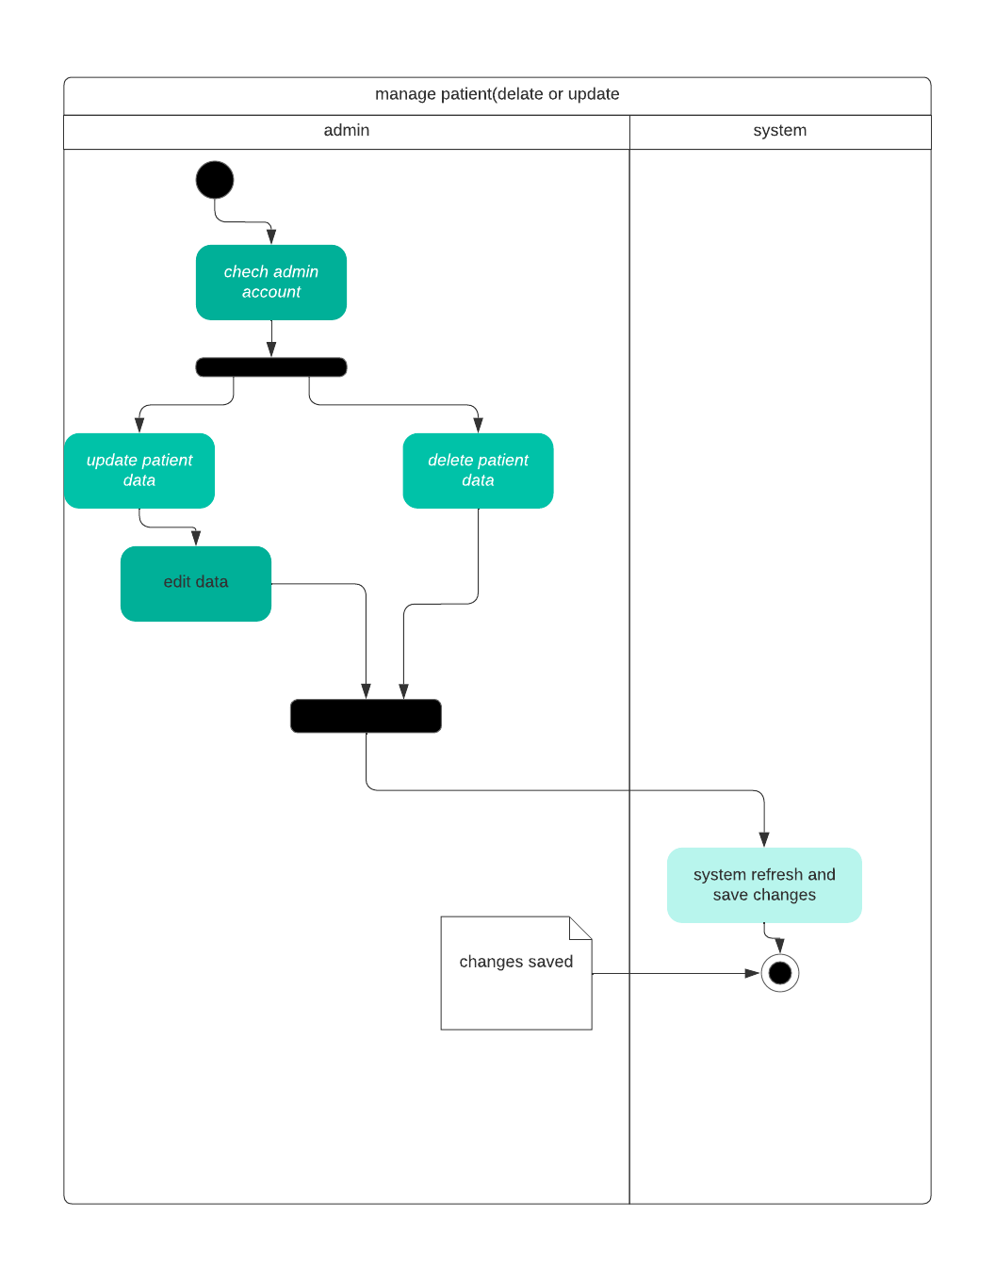

manage patient and admin (delate or update or add)

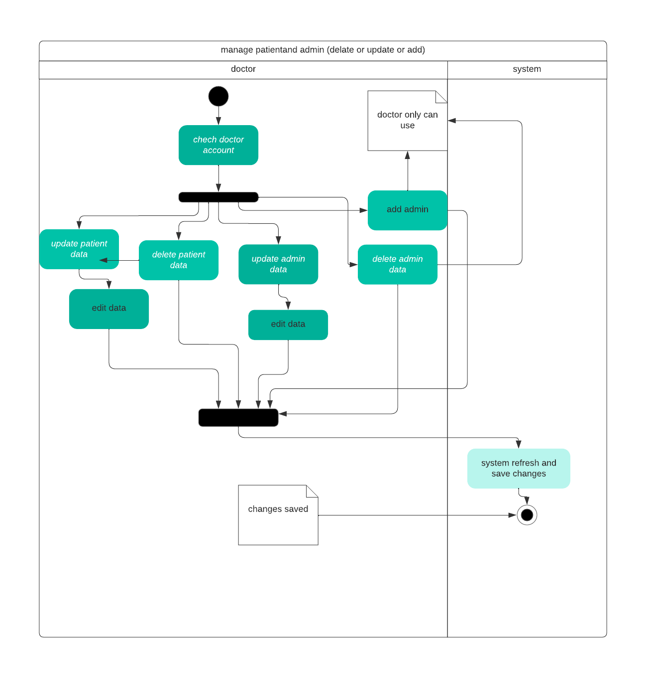

*Reservation (dashboard):*

*Admin # dashboard* 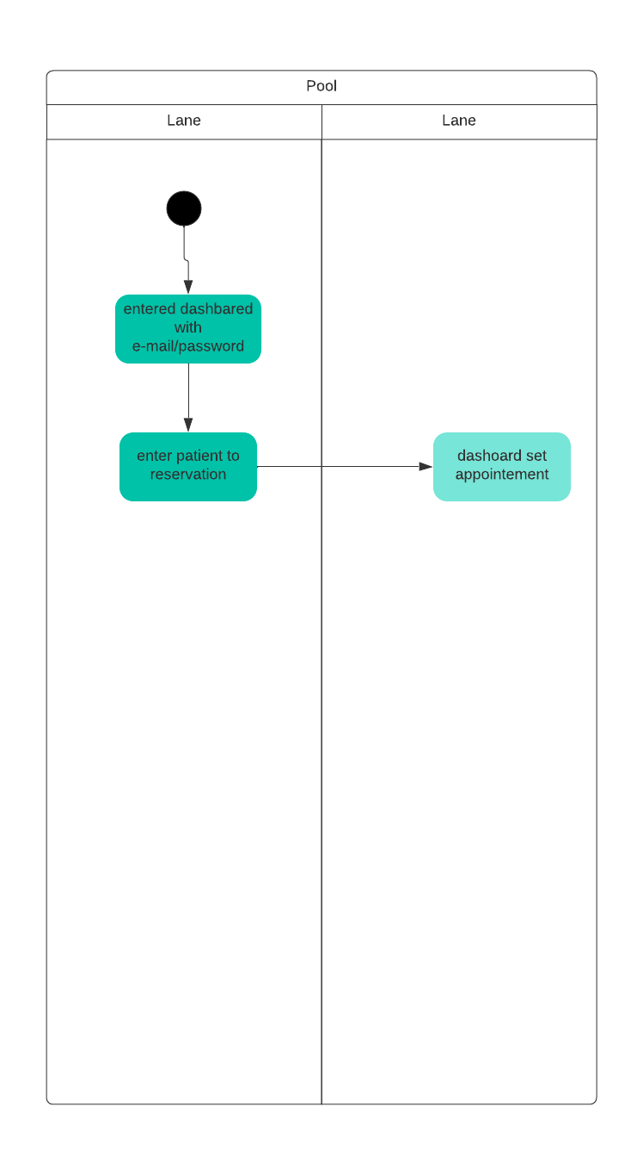

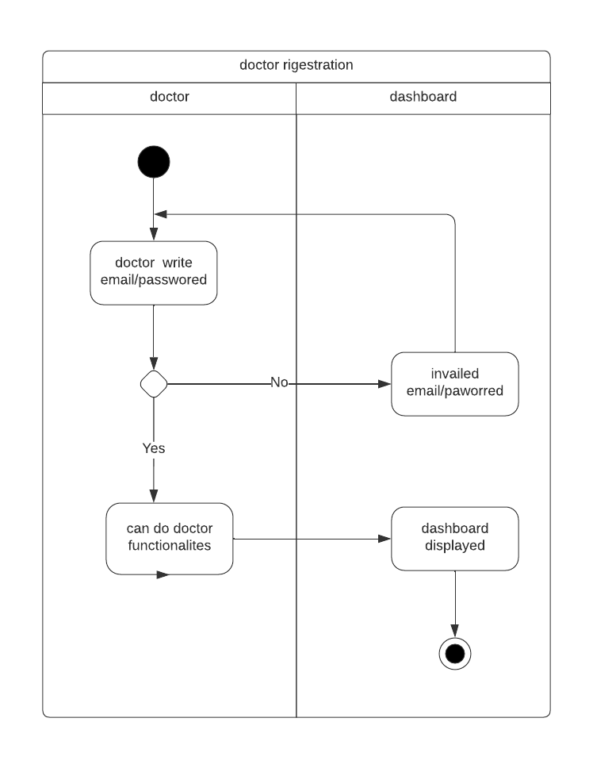

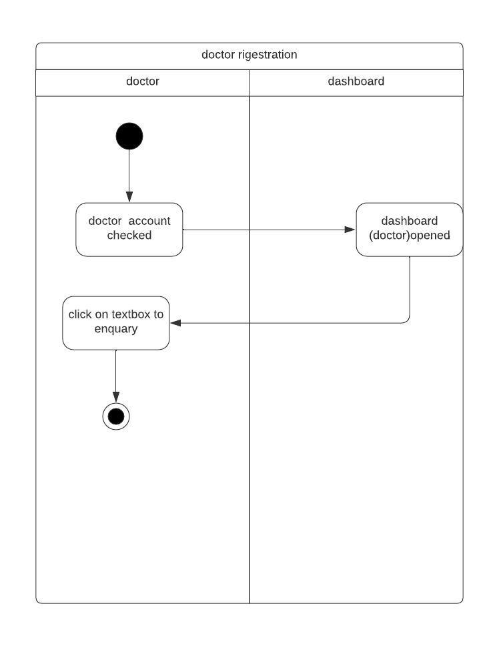

*5. Other Nonfunctional Requirements*

5.1 Performance Requirements : -

The performance of the system on the Internet depends on the user's device and the power of the servers used

The normal user login time is two seconds, the normal time to load a website page is one second, and the user query time is five seconds

5.2 Safety Requirements : -

The site guarantees the safety of the information by making backup copies of it, and this information can only be accessed through the owner of the system (the doctor) through the operations provided to him through the system

5.3 Security Requirements : -

And to protect the data more, we will show the site every period of time to an information security engineer in order to discover any gaps in the site and thus provide more protection

5.4 Software Quality Attributes : -

Available : The site will be available user within 24 hours

correctness: on site With specifications and the task used by Where to inquire about dates and book through the website

Efficiency: The user does not need a lot of time to perform the service

wanted from the site

Flexibility: where the admin can and The doctor can make adjustments and add new appointments through their control panel

Integrity: where only one can access the database Dr. and Admin through the username and password

Portability: where he can The user can access the site through any operating system

usability: where he can The user performs the required service on the site with ease

5.5 Business Rules : -

In the clinic system, in the event that the user is unable to log in, the reason is that the account does not exist in the first place, and a request will appear for the user to register on the site, and in the event of forgetting the password, the system will allow him to change his password by sending a message to the mail or phone number And in the event that the site is not loaded on the devices, a message appears indicating that it can be accessed at a later time